Web development wireframing pics

Matthew Spriggs

Web development assignment, wireframing

12/10/2024

I don’t know if I’m meant to put dates on these, but since it was all done in one day I’ve just put the date at the top of the document.

[This text means me coming back explaining stuff after I’d finished that part]

[I did the wireframe for a desktop first, I’ll add the one for mobile in later. ]

The black around the image is just the background of where I made this wireframe, it is not part of the design.

For each tab at the top, I’ll add a drop down screen that covers initial web page. In this drop down section, I’ll add some text explaining things relevant to the tab (if this doesn’t make sense, I’ll have pictures of it later on and it’ll probably be easier to explain it).

[My initial plan was to have each tab have a drop-down section for each tab when selected, this would consist of a link to another page. I literally immediately realised that this was completely useless; but I still wanted to keep the idea because it was a cool feature, so I decided I’ll add a bit of text for each tab explaining stuff (like what the page will actually be about), and then add the link.

This was changed though later on as there wasn’t too much to add for some of the tabs, so instead of going to another page, they’ll just have the required info. For tabs where there is a lot of text, then, I’ll add a link. (The map, which I add to the top tabs later, doesn’t count for this rule).]

So when the “Contact us” or the “Where to find us” tabs are selected, the box will expand and there will be some text about how to contact Cantor college and where to find it (depending on which box is selected). If one ‘box’ is open and the other tab is selected, the already opened box will close.

[This will not be affected by the tabs at the top which I explain later on.]

The “Campus Map” tab will take the user to another page consisting of an image of the campus map, a title and, whatever little explanation is needed to show the user that it’s a map of the campus (which hopefully they won’t need but I might as well add it just in case).

Another thing I should take note of is that, the grey boxes are images (I just haven’t finished yet so I haven’t added the diagonal lines to symbolise that it’s an image). I was thinking of have the Cantor college logo image in the top left.

You may notice that there is an image in the background as well, this will be just like a background (I am going to assume that this is obvious but I should mention it anyway), this can be either the actual background images from the resource folder or an image of something to do with the college (Cantor college of course). It doesn’t matter too much about what I choose as the user will barely see it anyway.

Now before you say anything, I realise that this wireframe looks kind of messy; however, as an engineer I have been taught that sketches should be messy but easy to understand, not pretty and confusing (I’ll tidy it all up when I’ve finished the design).

I have decided that instead of just having a bit of text explaining stuff then a link, I’ll only add a link if there’s a lot of text. I also have decided that the map to a tab as well. I’ll have some text (“this is a map” would be kind of insulting so I’ll put something more professional when I actually make the website) and an image of the map. I’ll make the image is big, but just in case, there’ll be a link to another page, with a map pic that can be zoomed in on.

[There will also be a scroll bar shown beneath the navigation bar at all times]

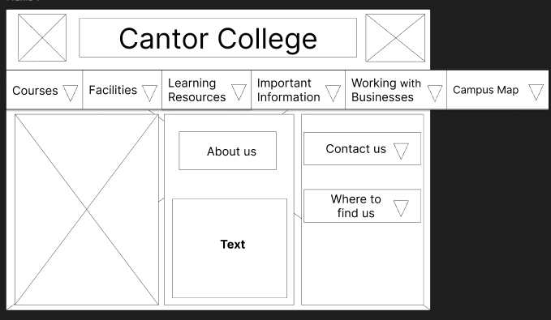

The ‘arrows’ will only appear when the tab is hovered over with the mouse.

The row of tabs that appears to go off of the initial frame represents what can be shown if the user hovers over the tabs with their mouse and scrolls (the tabs will scroll horizontally). Basically, the user will hover over the tabs, then when they scroll the tabs will move horizontally. (Up-down = left-right).

(It doesn’t include my mouse in the screenshot but imagine a cursor is hovering over the “facilities” tab). The ‘arrows’ should be invisible unless the ‘arrow’ of the tab is being hovered over. This doesn’t apply for the “Contact us” and the “Where to find us” tabs.

[When a tab is selected, selecting the tab again will make the drop down section go away. Selecting another tab will replace the drop down section that is active.]

Here is the initial page wireframing. Having it all fit so nicely on a 1440 x 1024 desktop screen, was not initially part of the plan but (I expected it to be big enough for the user to scroll), but it actually look quite nice like that.

I was going to have the “Contact us” and the “Where to find us” tabs expand when clicked on (this would thus make the page bigger when selected and the user could scroll). However, there was not that much information for the two tabs so I decided that feature won’t be necessary.

You may also notice that I readded the “Campus Map” tab. I did this because “Campus Map” on the top tab is all the way to the right; the user might not know it’s there. Instead of swapping the location of the tab with a different one (and risk the user missing that tab instead), I’ll make it so that the “Campus Map” tab in the “Contact us” box (that’s what I’m going to call it so I don’t write “Box with the Contact us and Where to find us tabs” all the time) will move the top tab and show the drop down section for “Campus Map”. As if the user scrolled to “Campus Map” on the top row and selected it.

The row will also show a scroll bar underneath when the mouse if hovered over it, this is so the user knows that it can be scrolled across.

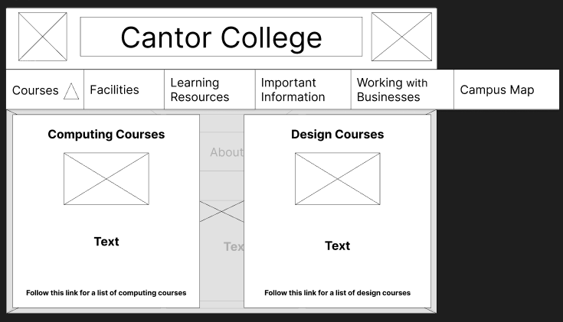

So, this is what the user would see if they clicked the “Courses” tab. The height of the boxes will adjust depending on how much text there is. You may notice that I have put an image for the background. This image will be visible but of course covered by the two boxes. If the user scrolls, it will on scroll on the dropped down section. Once they scroll past the background image, they will see the initial page in the background but blurred. This will apply for all the drop down sections except the map.

The user can scroll on the row of tabs at all times (as long as their cursor covers it).

Both the link for computing courses and design courses will take the user to the same page, but the screen will jump to the appropriate section.

The row of tabs will scroll to be fully shown when selected (the reason I haven’t done that in the picture is because it would be very time consuming to move everything along just to show one little thing).

The image is going to be the map. This image will probably have a lot more height and maybe less width. The user will most definitely need to scroll down a little bit to get the full image of the map.

Where I put text, there will be table, like what is provided in the resources. It will look nice when it is actually made.

Finally this is the page where the view can not only see a larger version of the campus map, but they can also zoom in, and download the map.

I decided to put the contact us in the footer with some other links too. The images will be icons for social media platforms (like Facebook), they will also work like links. These links won’t actually go the Cantor College Facebook page (for example) as it doesn’t exist. They will however take the user to Facebook (or whichever social media platform corresponding to the link they pressed).

Bellow the links will be the same contact information as before (phone number, email, etc). The email will also be copied to clipboard when selected.

There’s also a copyright notice link (this too however is also going to have to be fake).

Since there was some extra room, I decided to expand the campus map box and will put a small image of the map in there. When the box is selected (as opposed to just the “Campus Map” title), the user will get taken to the campus map drop down section. I don’t expect the user to be able to effectively use the miniature campus map picture; I put it there because, one it looks nice and, two it will give the user an idea of what the map is like.

15/10/2024

Now I’m going to do the wireframing for a mobile device. I should mention that for tablet the wireframing of the website will just be the same as desktop. Of course, adjust the sizes may have to adjust, but that will literally just be the case of adjusting the format of text so that the pages scroll instead of things being off the screen. (This will also be useful if the user switches their laptop between landscape and portrait).

[This is a copy of my desktop wireframe]

Now first I need to decide on the size of the frame (of course, the screen is going to adjust based on the size of the user’s screen; but I need an average screen size to work with). iPhone 14 pro seems suitably average. This isn’t too important but anything to different from what I design will not look as good when adjusted; and I need to set a limit to what width is considered a phone screen. (it’s mainly the width I need to worry about).

Now all I need to do is remove any unnecessary images (as you may see I’ve already deleted some). Then just adjust the size and placement of everything.

The footer will pop up when the user scrolls down.

The drop down sections will follow a similar pattern, just as the other pages will.

I have decided that I will have all of the navigation bar shown. This is because the user might not realise that that can scroll. This will apply for mobile and desktop (and ipad), there will be no need for the miniature campus map box next to the where to find us box. This will leave lots more space for me to add text further up the screen on mobile.

For now I’ll just keep the footer as something at the bottom of my page, not something that pops up when the user scrolls down.

I think I can say I’ve have a clear idea of what I’m going to do so I can now start with actually programming the website.